UPES PYTHON LAB ASSIGNMENT

***EXPERIMENT- 14***

***Name- Anmol yadav***

***SAP ID – 500083814***

***BATCH- B8***

Q1.

a. Convert numbers =[1, 2.0, 3] to numpy array and convert all elements to string type.

b. Create a 2 D array through list and set dtype as int32

c. Find the rows and columns of the 2d array created in part b

d. Print 10 random numbers between 1 and 100.

Sol:-

a)

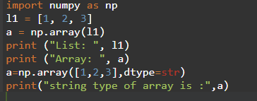

Output:-



Part- b and c )

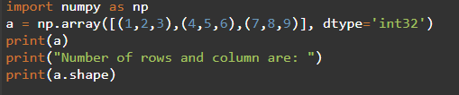

Output:-

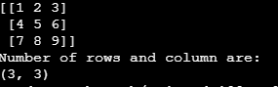

Part –d )

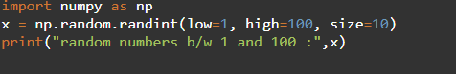

Output:



Q2.

1. Write a NumPy program to get help on the add function
2. Write a NumPy program to test whether none of the elements of a given array is zero
3. Write a NumPy program to test whether any of the elements of a given array is non-zero
4. Write a NumPy program to generate an array of 15 random numbers from a standard normal distribution

**Sol:-**

**Part- a)**

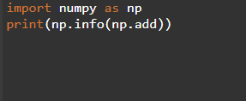

**Output:**

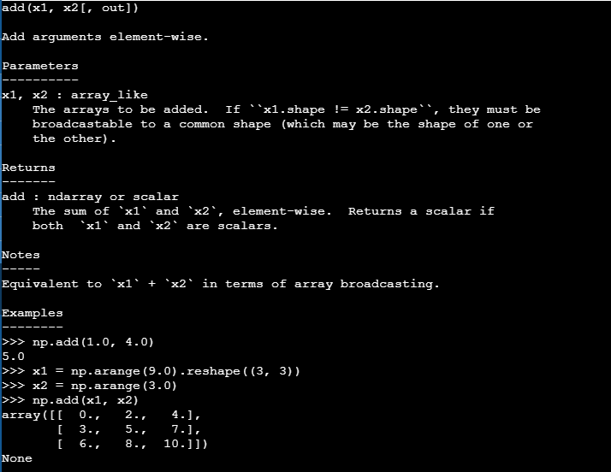

**Part –b and c)**

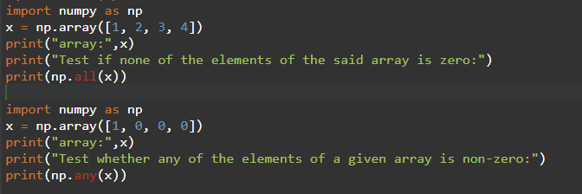

**Output:**

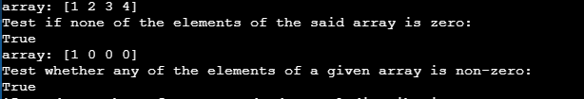

**Part d)**

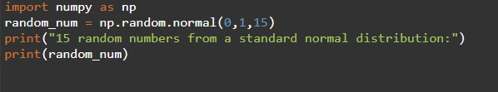

**Output:**

